Assignment 1:
Integrate the Jira to the exiting userstory to testcase generator codebase
This is the overall requirement and Hint for Jira integration Assignment.
Requirements:
- Add a “Connect Jira” button in UI page to establish a connection (Base URL, email, API token).
- After successful connection, show a dropdown listing all user stories.
- Add a “Link Story” button that fetches story details (Title, Description, Acceptance Criteria).
- Add backend connectivity to Jira.
- Once connected, populate the stories; on Link Story, display the details.
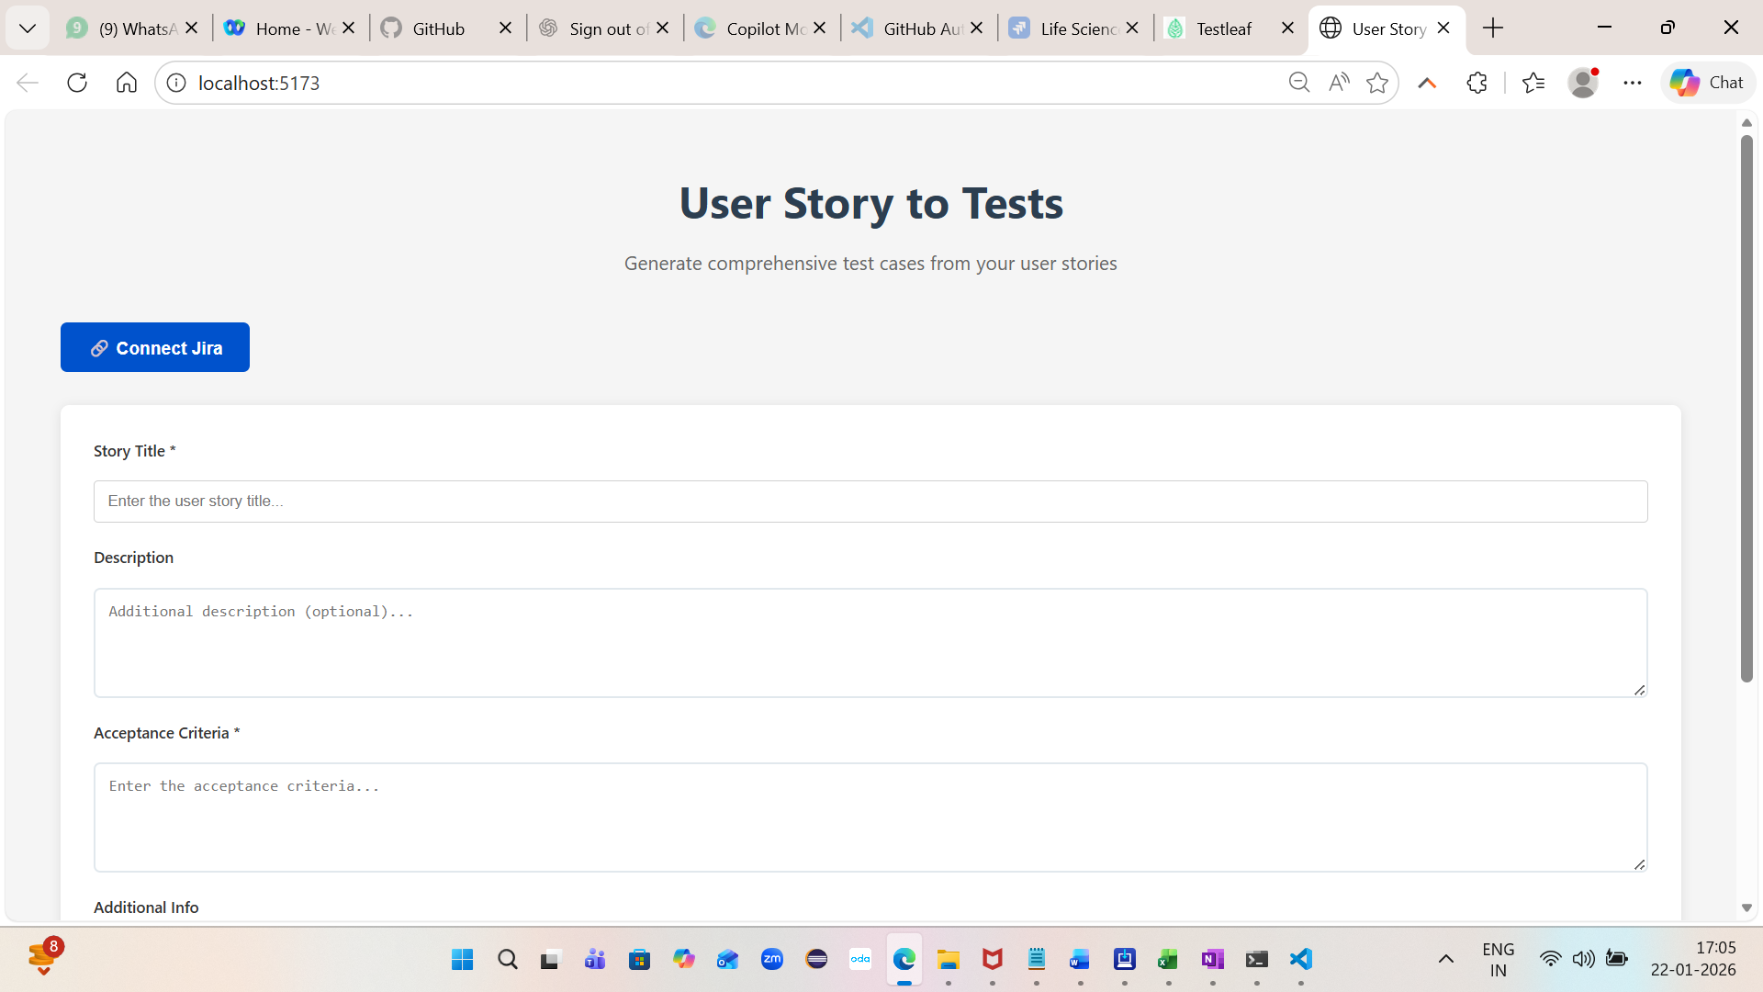 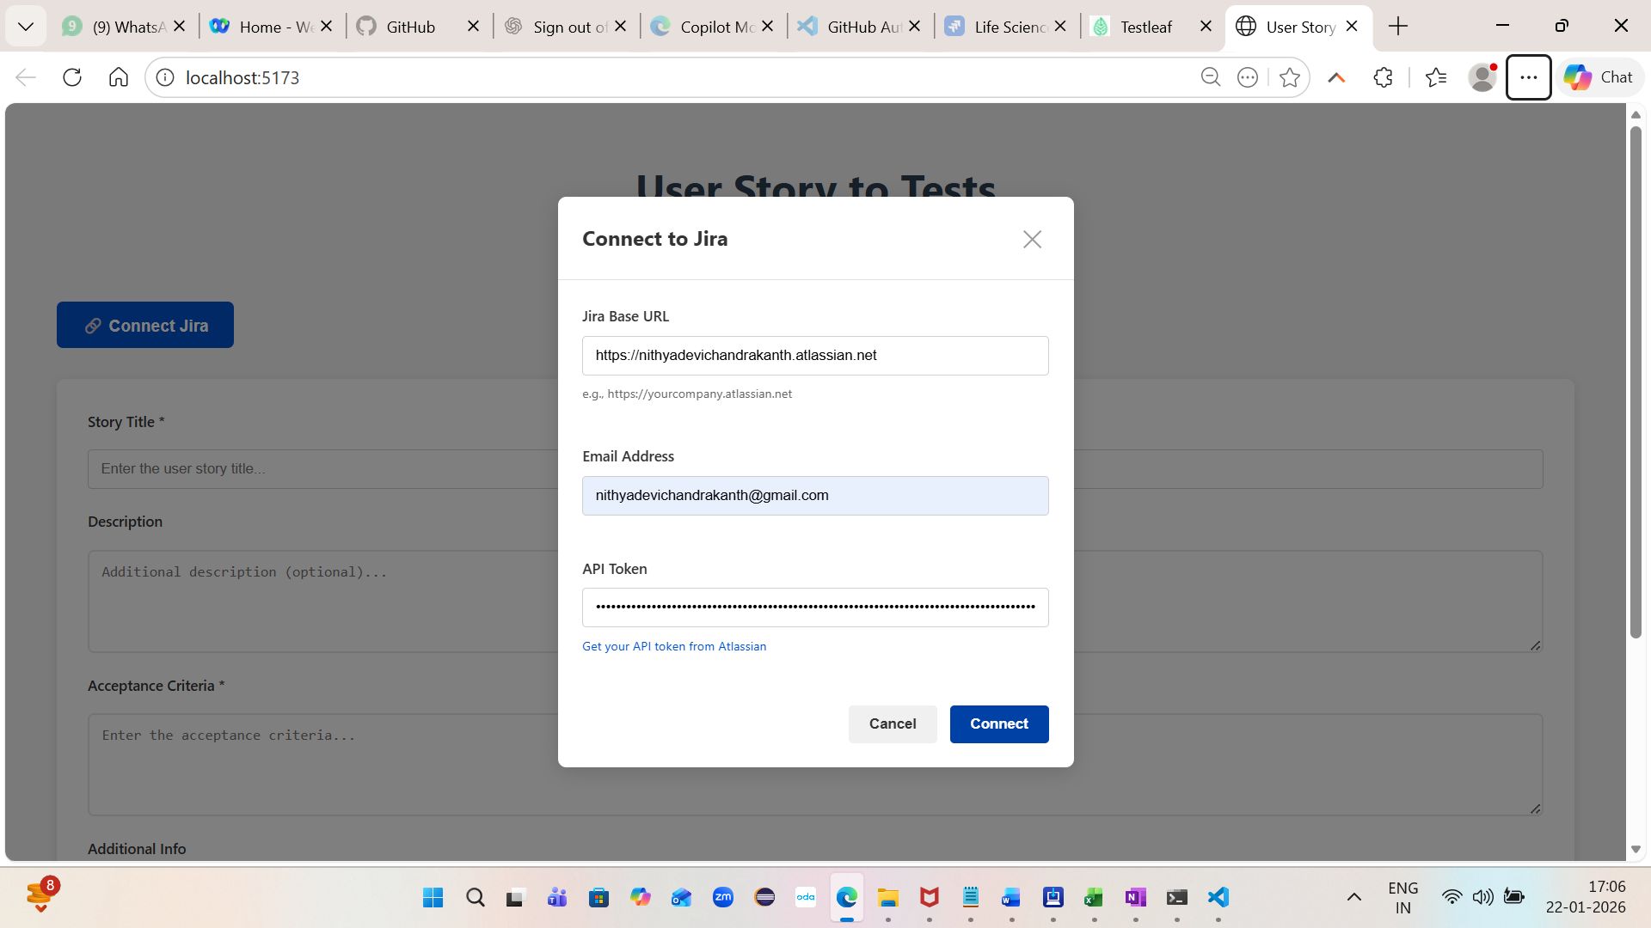 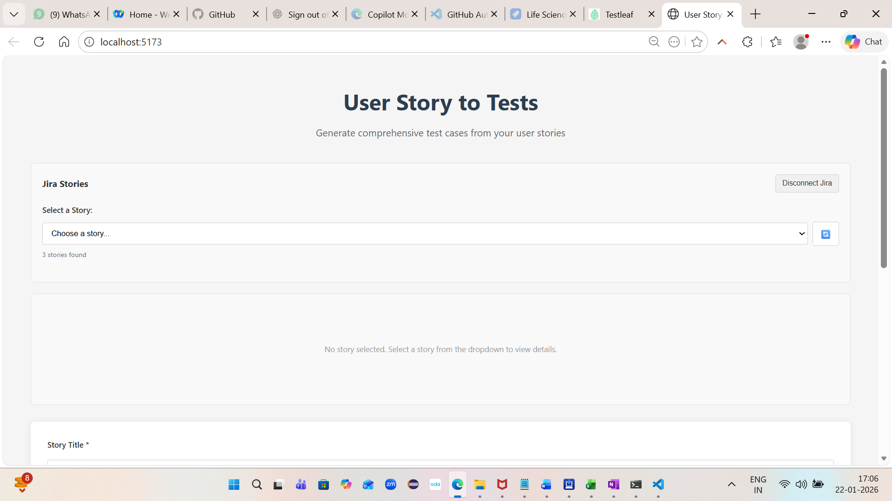 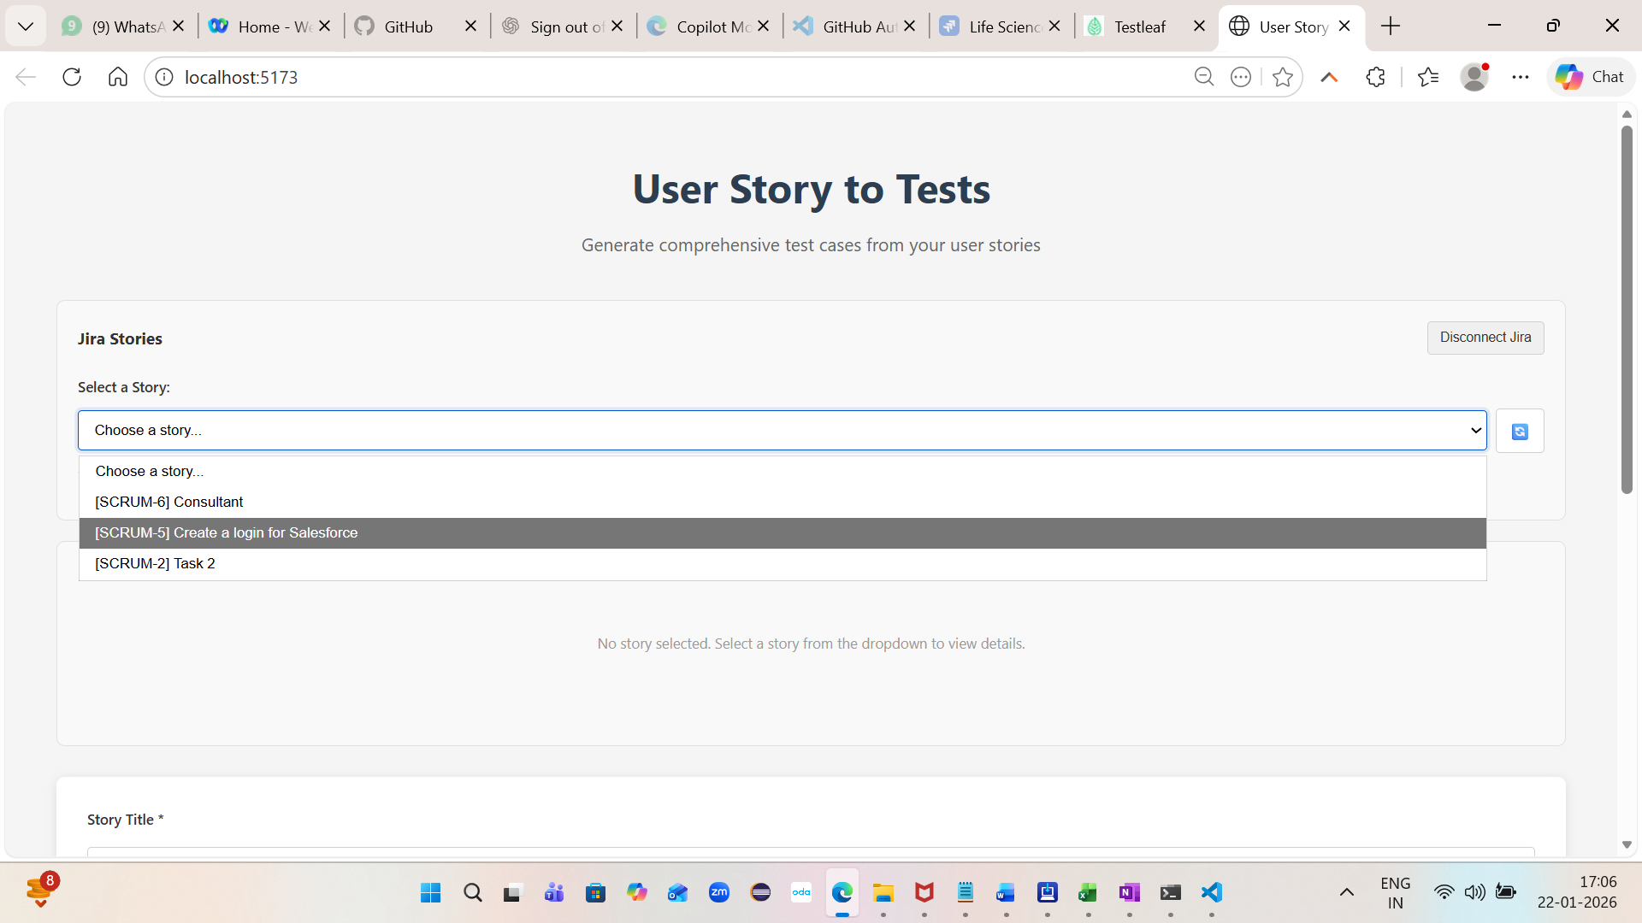 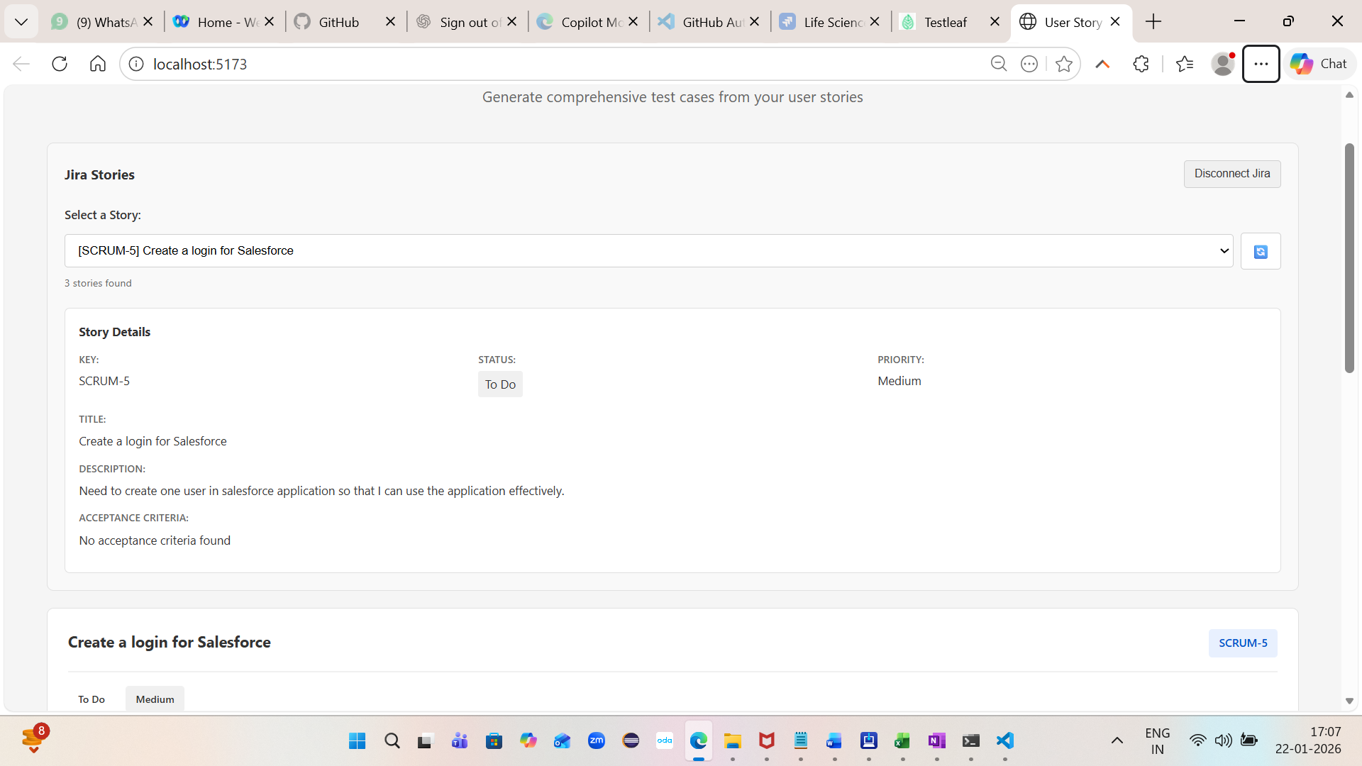 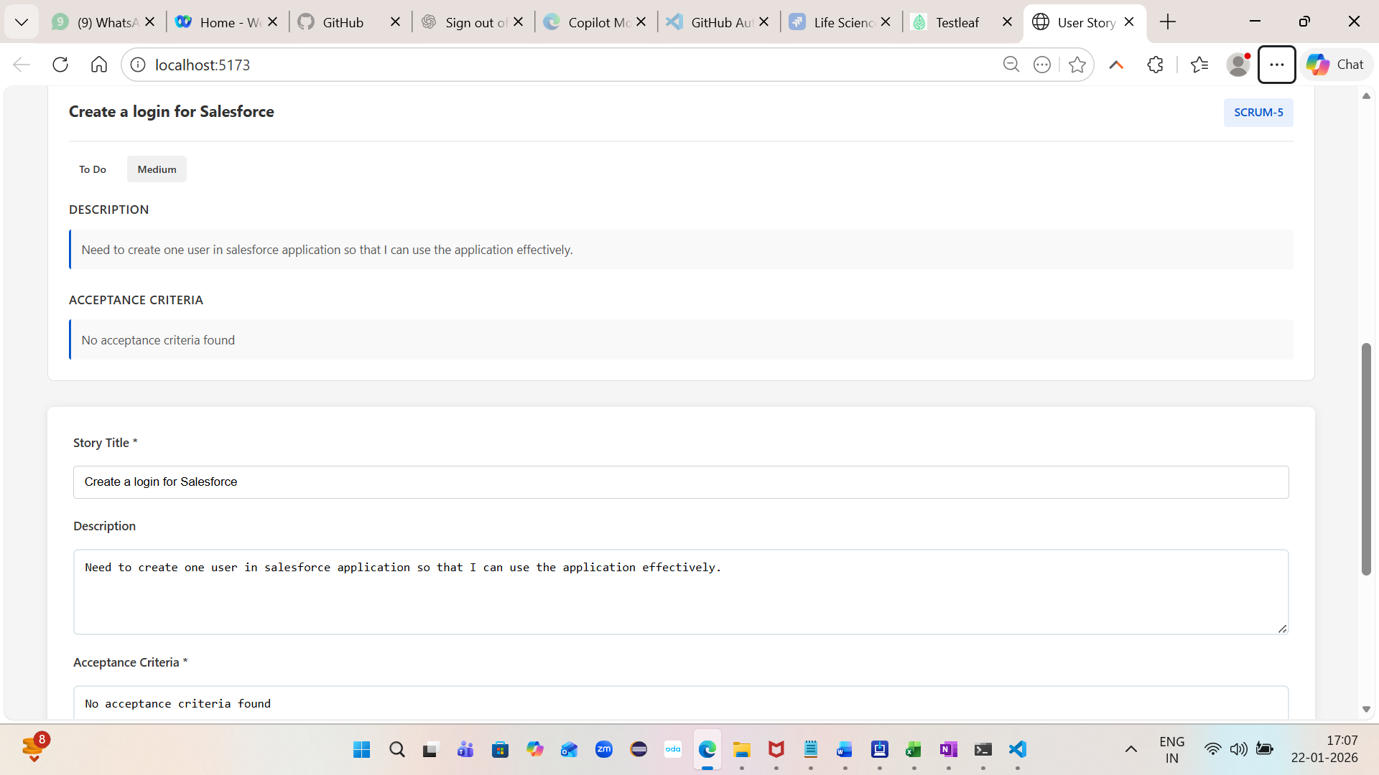 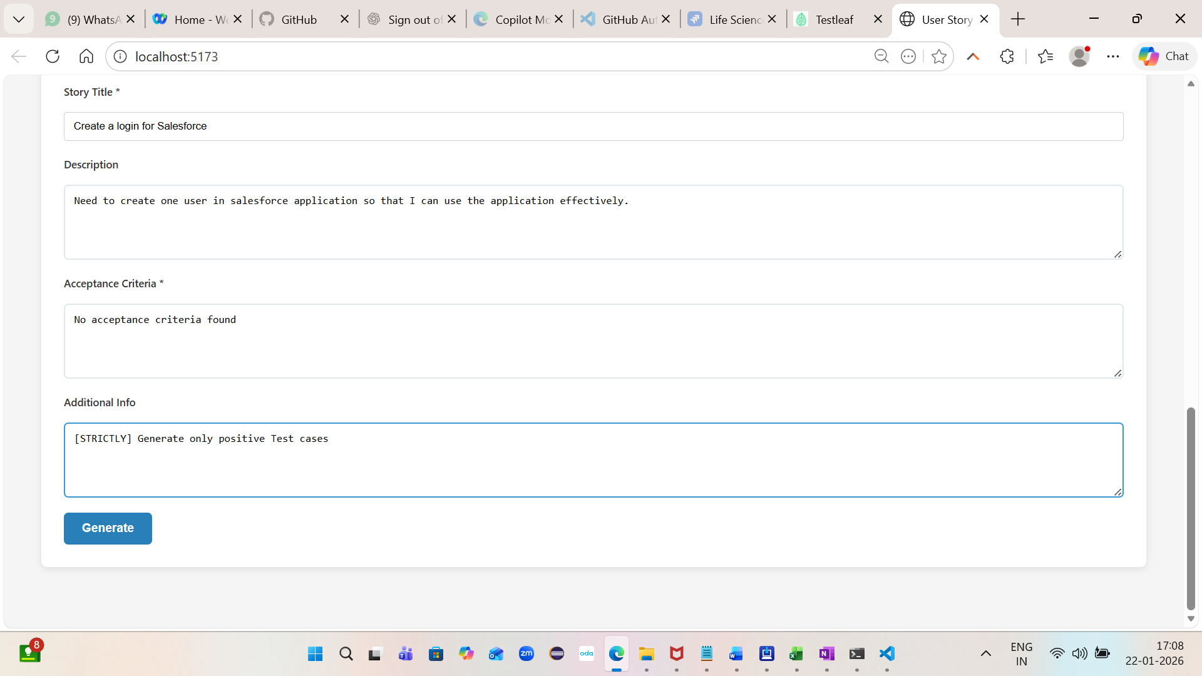 Assignment 2:
Add a download button in UI with the formats like XLSX,PDF,CSV. 